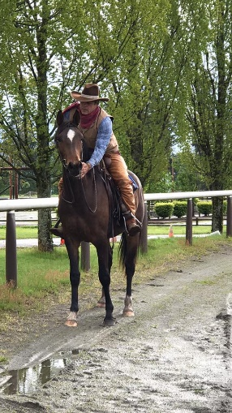
JOSE ALEJOS:
Jose returns to the Pacific Northwest:
World renown young horse starter and Master horsemen Jose Alejos. Jose will be returning to the Northwest at Donida Farm, located in Auburn WA, Oct 18 (Tuesday) through 29th, 2022. This fantastic training seminar is filling up fast. Multiple divisions available. Prices include Permanent box stall, tack-up, cool-out, hacks, fabulous experience and confidence gained. Continued services following the training session of Young Horses may be arranged.
Jose Alejos, is an athlete, a horseman, mentor, and we are privileged that he is willing to share his experiences with us.
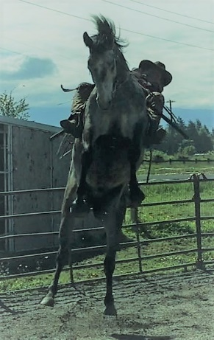
1) “Backing”: The program for backing of the unbroke horse. For horses never been started under saddle $1,500 payable to Jose Alejos. Additional $700 board payable to Donida. $1,000 deposit required. none refunded
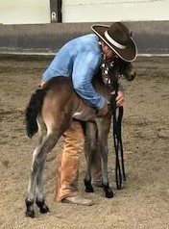
2) “Difficult horse”: Rearing, bucking, bolting, bullying, bad stallion behavior, etc.) These horses may only need a few days of explanation/correction/evaluation or up to two weeks. Training days priced by Joseon site. Haul-ins payable to Donida @ $45.00 day. Day holding stall. $500 non-refundable deposit payable to Jose.
3) “Life lessons”: Halter breaking while instilling confidence with leading. Along with weaning in a group. (Yearlings thru 2 year old accepted as well). Individually priced by Jose Haul-ins payable to Donida @ $45.00 day. Day stall. Contact Gwen for info. $200 non refundable deposit payable to Jose.
4) “Individual rides”: available as well with personal consult. Individually priced by Jose Alejos. Haul-ins payable to Donida @ $45.00 day. Day stall. Contact Gwen for info. $200 non refundable deposit payable to Jose.
Owners will learn how to deal with their individual horse by the end of this seminar. Riders will usually be on their own horse and going for group trail rides aboard their newly broke horse!
Professionals expressed concern that they do not have time to start young horses as they have to focus their time on training and coaching, novice and advanced clientele. The inherent risk of starting young horses is widely acknowledged.
The most proficient riders, trainers, or athletes are the ones who practice their skills every day. An Olympic competitor trains every day to become a champion in their sport, so should the horse trainer! Sport research concludes that to become one of the elite global athletes in any sport, it requires a minimum 10,000 hours of training and practice to breach the high-performance level, let alone be the champion. The presenters in this series are top athletes and coaches in the discipline of starting young horses. It is estimated they have well over 90 000 hours in their field to date.
From Jose -"I travel the world starting young horses and addressing training problems in horses and their riders for virtually every discipline. I’ve been doing this since I was 10 years old when I first learned the principles of horsemanship from my grandfather. I call my method “rational horsemanship” because it is based on the natural interactions that occur among horses in a herd. Rational horsemanship takes advantage of a horse’s natural reaction to pressure and, even more importantly, its reaction to the precise timing of the release of pressure, so that the horse becomes increasingly responsive to the rider’s aids (seat, leg, and hand). Using this method, I sense when the horse is just on the verge of giving to pressure, at which point I reward the horse with the release. In just a few short weeks, my rational horsemanship approach can produce a responsive, balanced and happy young horse that a professional or good amateur can continue working with in their specific discipline. Ultimately, my method establishes a secure foundation for each young horse I work with, whether they are hunter, jumper, dressage, eventing, or western riding horses.
When I travel to a farm, I typically work with 10 to 30 horses at a time. Occasionally I will work with less than 10 young horses or combine some colt starting with solving training problems in older horses. My programs typically run about two weeks, but I absolutely guarantee my work and I stay for as long as is needed to ensure that the riders and trainers are satisfied and comfortable riding and handling their horses themselves."
Donida Farm Equestrian Center fall 2022 Young Horse Seminar.
Contact: Gwen Blake 360-507-9306/text/call/message
A deposit payable to Jose Alejos will hold your spot followed by the balance due upon arrival. Special arrangements for Individual Difficult defined horses. All documents/releases/descriptions, information must be supplied with deposit.
Mail to:
Gwen Blake c/o Young Horse session,
16650 S.E. 376th street,
Auburn, WA 98092

